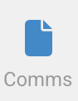

Billings Module

October, 2023

All the notifications sent by the system to the email/number on file can be viewed here along with time stamps of mail sent delivered and opened. In the event you miss or lose an email, you can search for it here.

# How To

## View and search for emails received while using the portal

To view any communication in the portal click on the Comms module, this shows the email information and content.

Use the search bar to search for specific emails.